HDI CATS
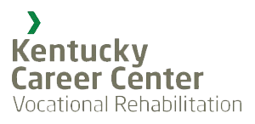
center for assistive technology services
with

2019 Spring Institute in Assistive Technology
March 28, 2019
8:30am - 4:30pm
Gatton Student Center, University of Kentucky

Sessions, user panel, and hands on demonstrations of a variety of AT devices.

Lunch will be provided
RESNA and CRCC CEUs available
FREE for students, researchers, faculty, staff and community members!
Featuring
Dr. Rory Cooper, University of Pittsburgh Rosi Cooper, University of Pittsburgh Dr. Phillip Rumrill, Kent State University Dr. Jarod Giger, University of Kentucky

Register online at
http://bit.ly/SpringATInstitute
Questions? Contact hdiatcenter@l.uky.edu

